**Bootcamp Project 4**

**Project Title: Incremental Data Loading and Automated Notifications using Microsoft Fabric**

**Problem Statement:** In modern data ecosystems, organizations need to efficiently ingest, transform, and load data from various sources into centralized platforms for analytics, while also ensuring timely monitoring and notification upon successful data refreshes. This project addresses the challenge of incrementally loading data from on-premises sources to Microsoft Fabric Lakehouse, processing it through a structured transformation pipeline, and triggering automated notifications upon successful execution.

**Architecture Diagram:** 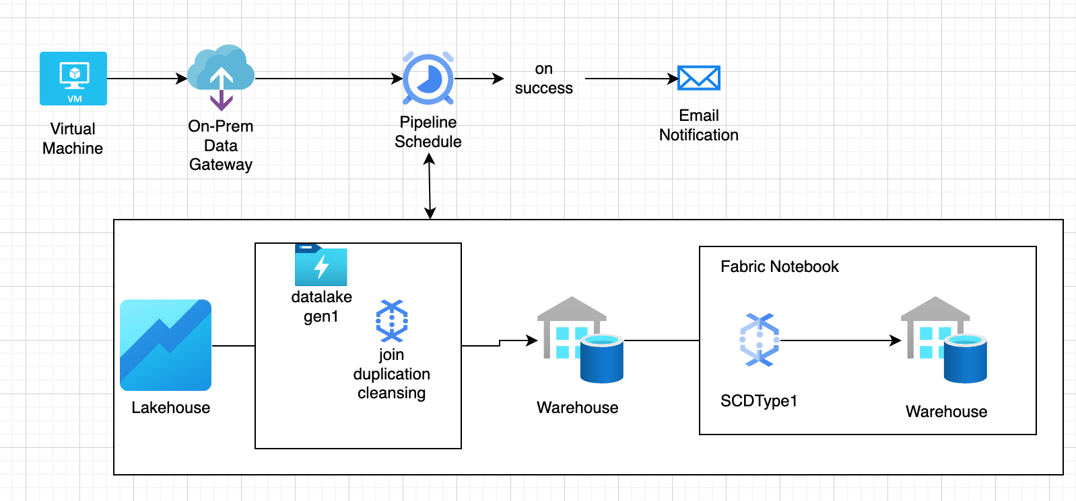 **Tools & Technologies:**

* Microsoft Fabric
* On-Premises Data Gateway
* Fabric Lakehouse and Warehouse
* Fabric Dataflow Gen 1
* Fabric Notebook
* Email Notification Task (in-built)
* Azure Key Vault (optional for secure credential management)

**Data Ingestion from virtual Machine to Fabric Lakehouse using On Prem Data Gateway**

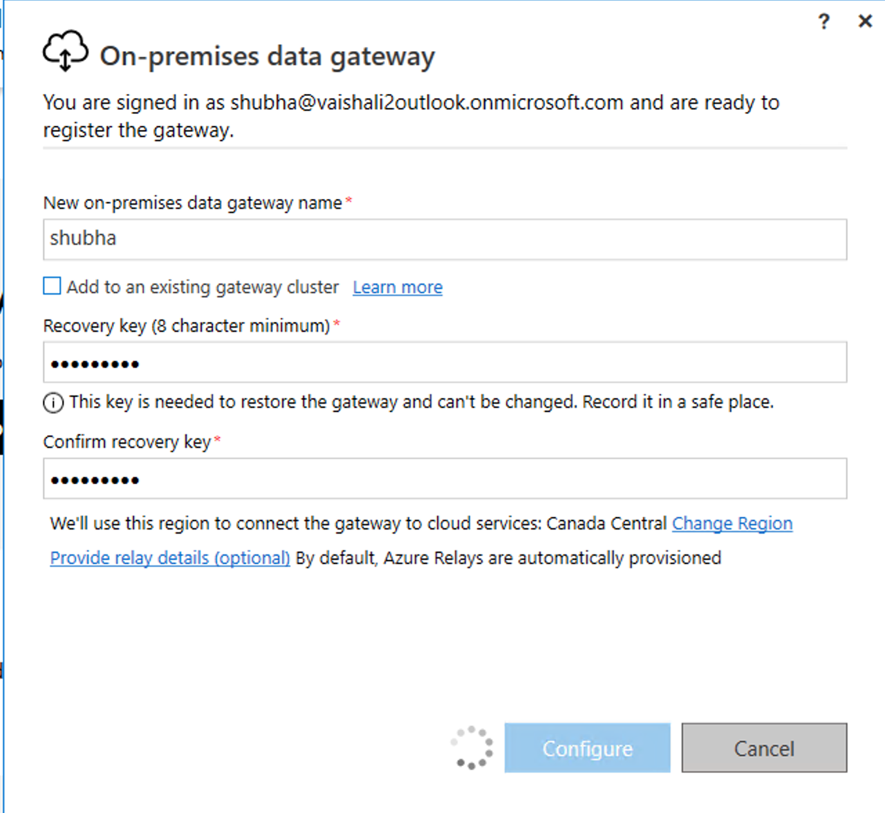 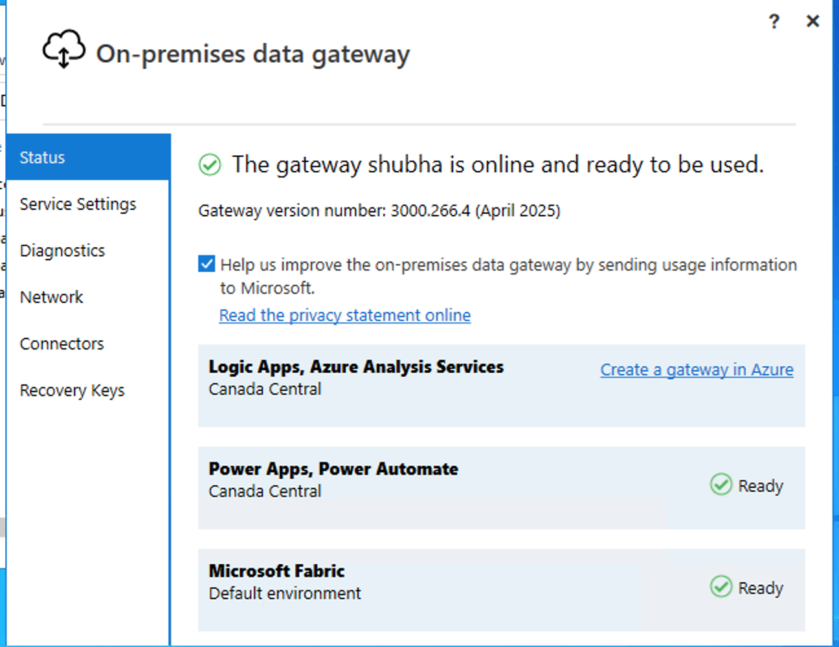Now check if data gateway status is online in fabric

Fabric 🡪 setting 🡪 manage connection and gateway 🡪gateways and check if it is online 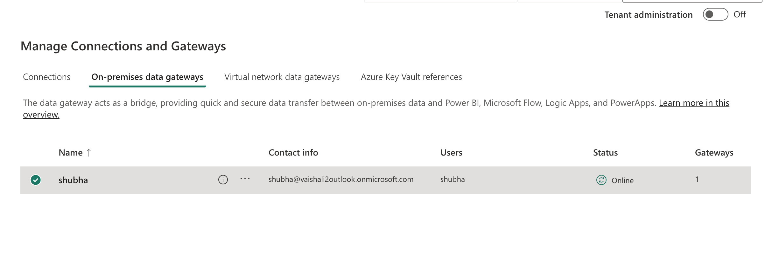 and create a connection(linked service)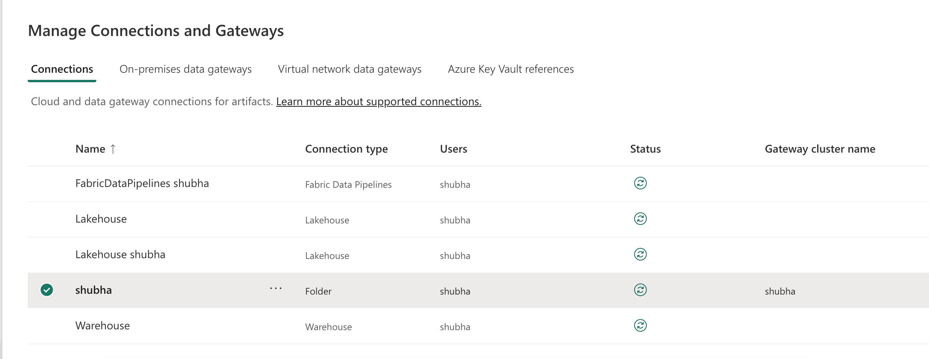Now create a pipeline to ingest data from Virtual Machine to Lake house 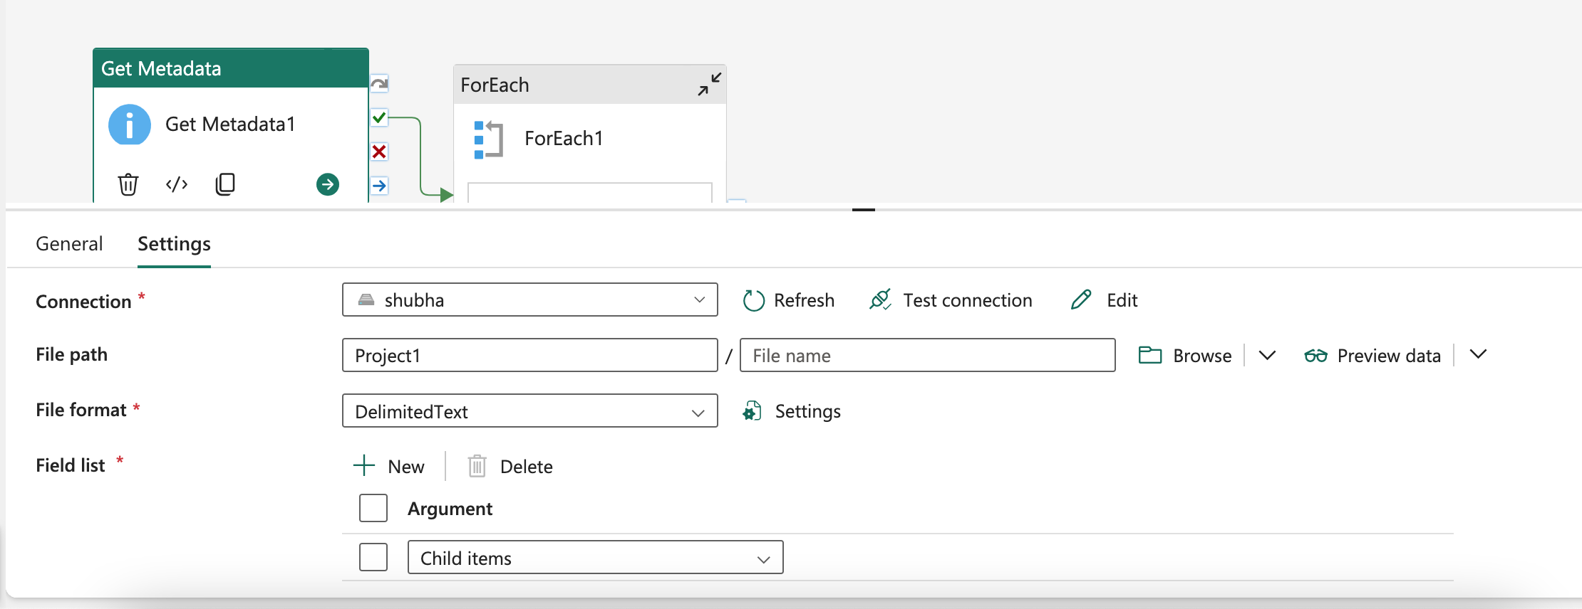 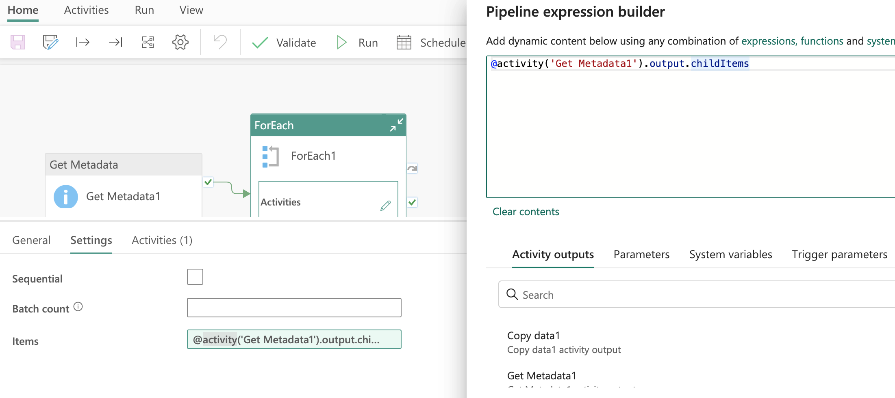 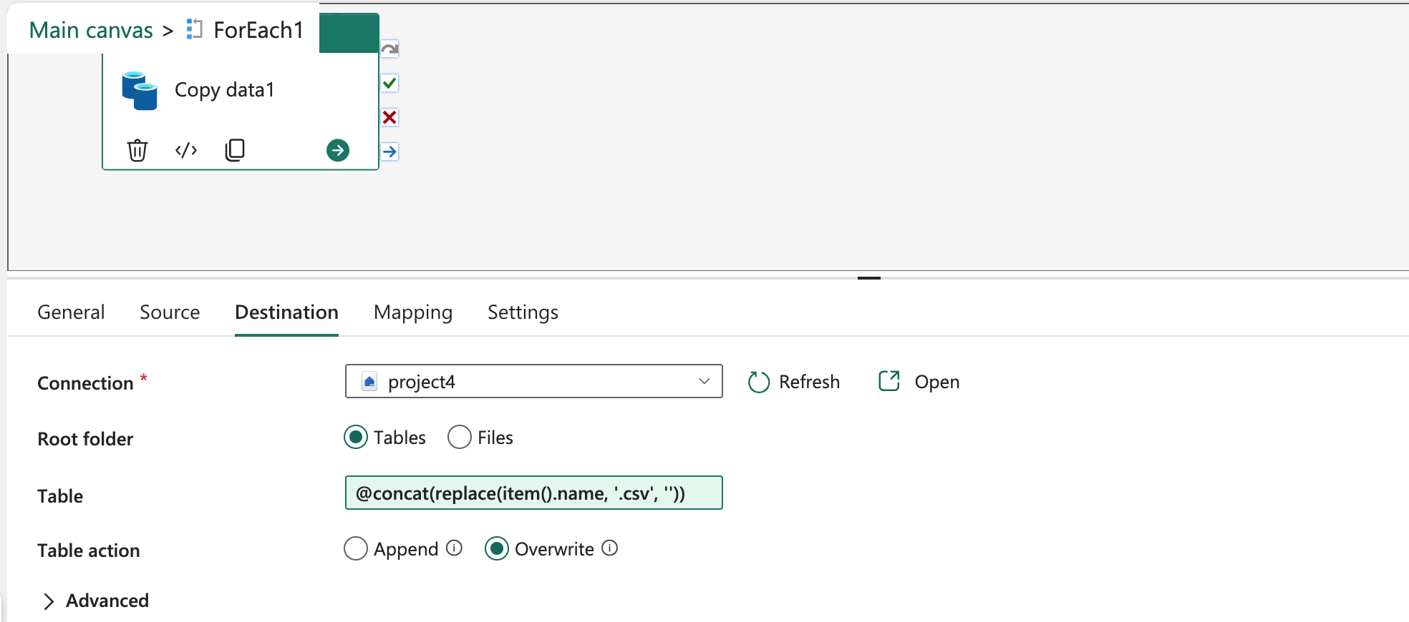 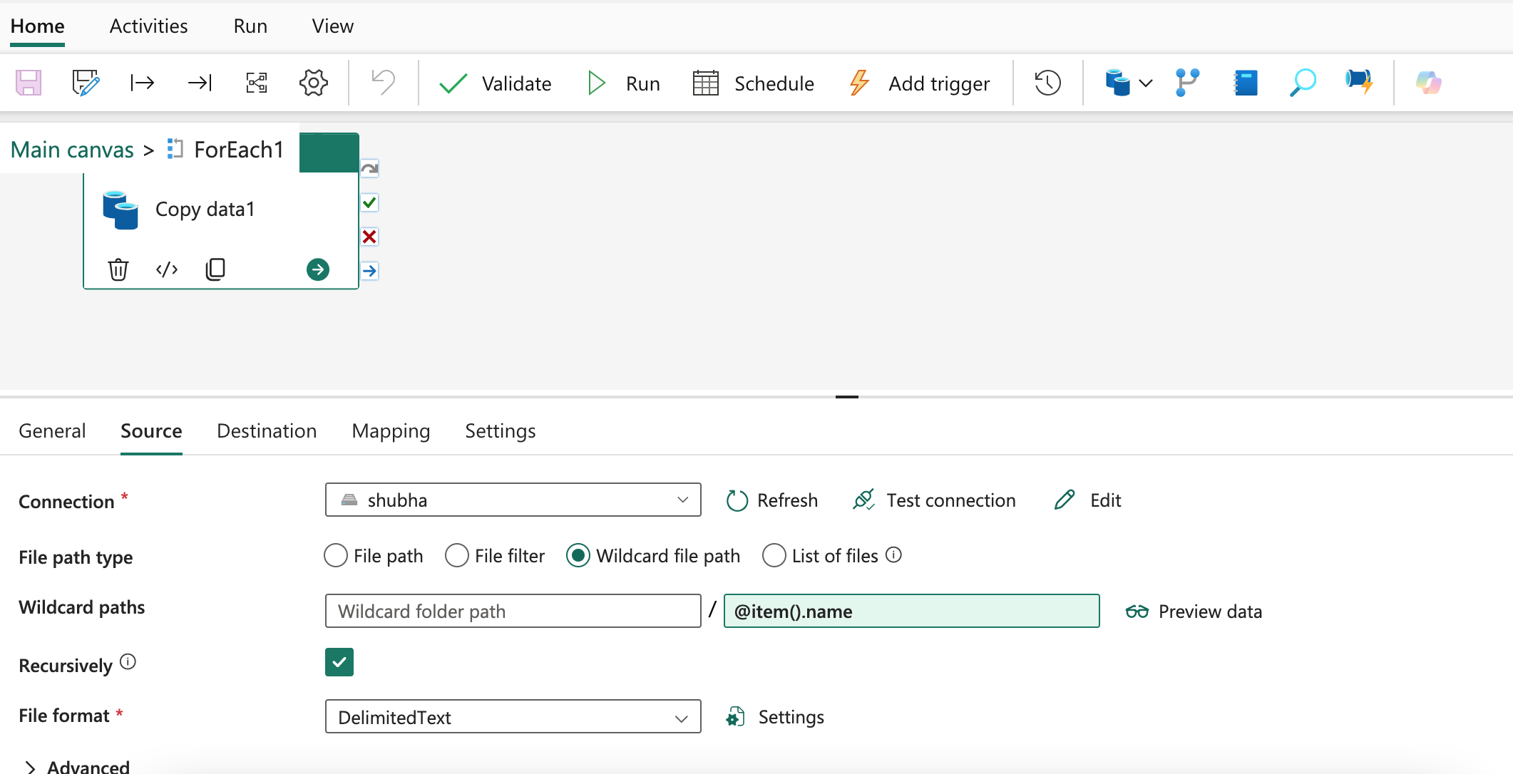data got successfully loaded in lakehouse 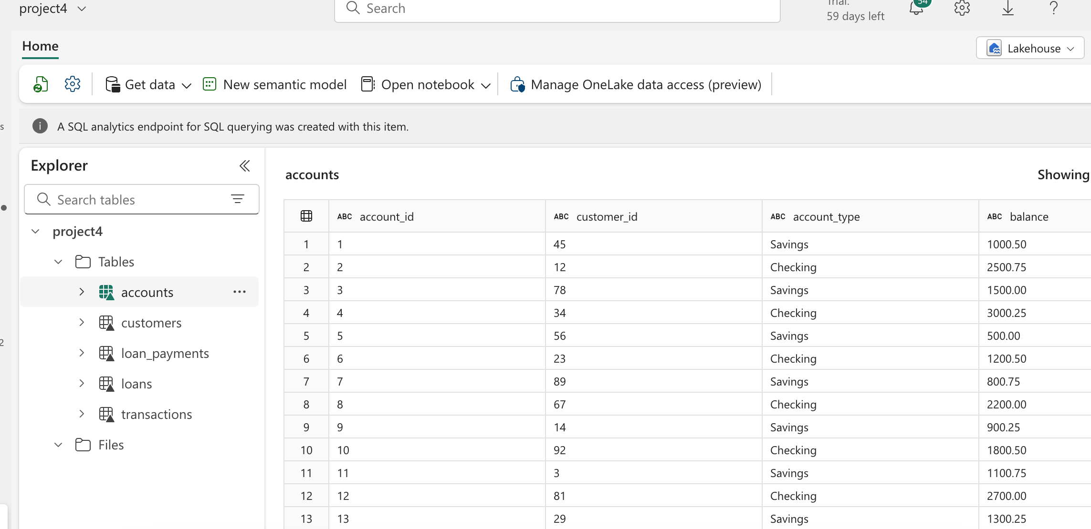Data cleaning and transformation using dataflow gen1 and storing in warehouse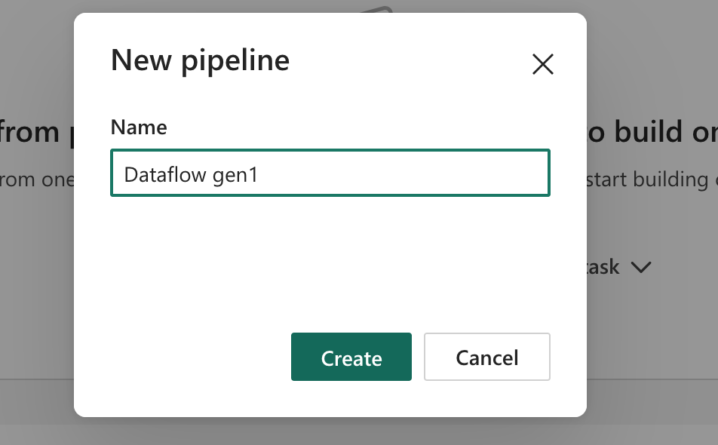 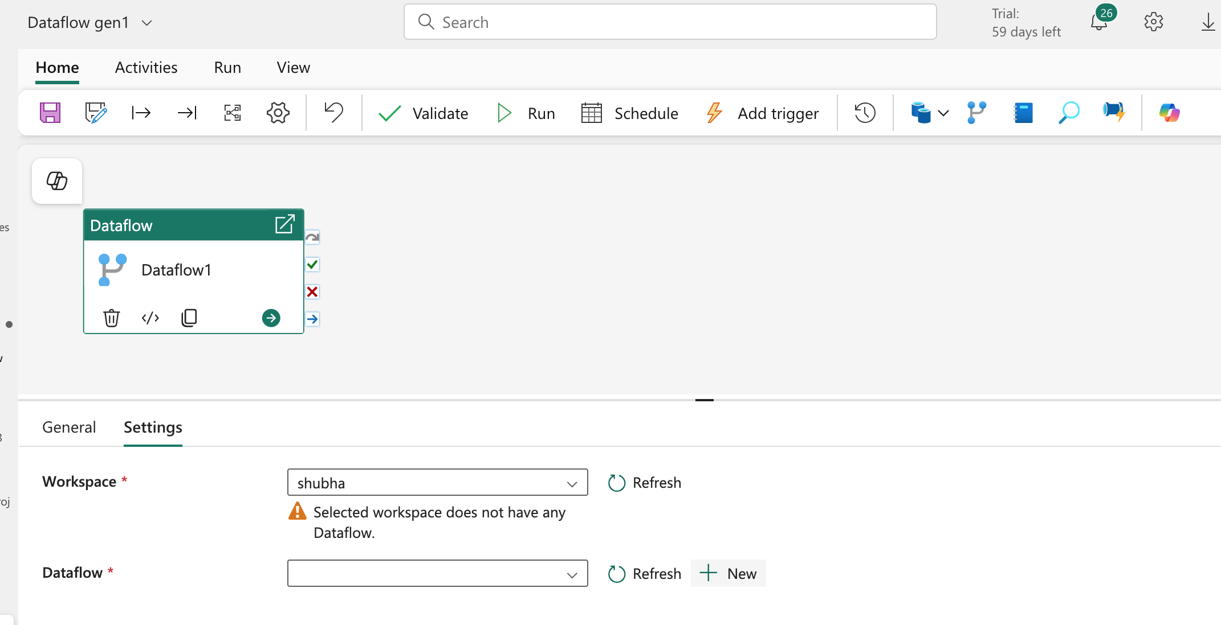 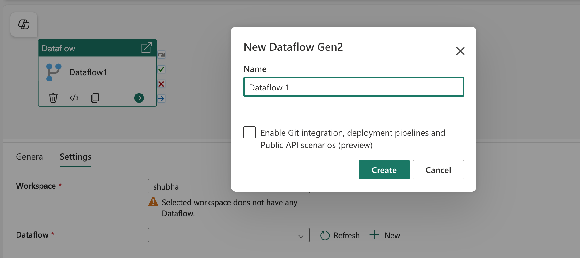 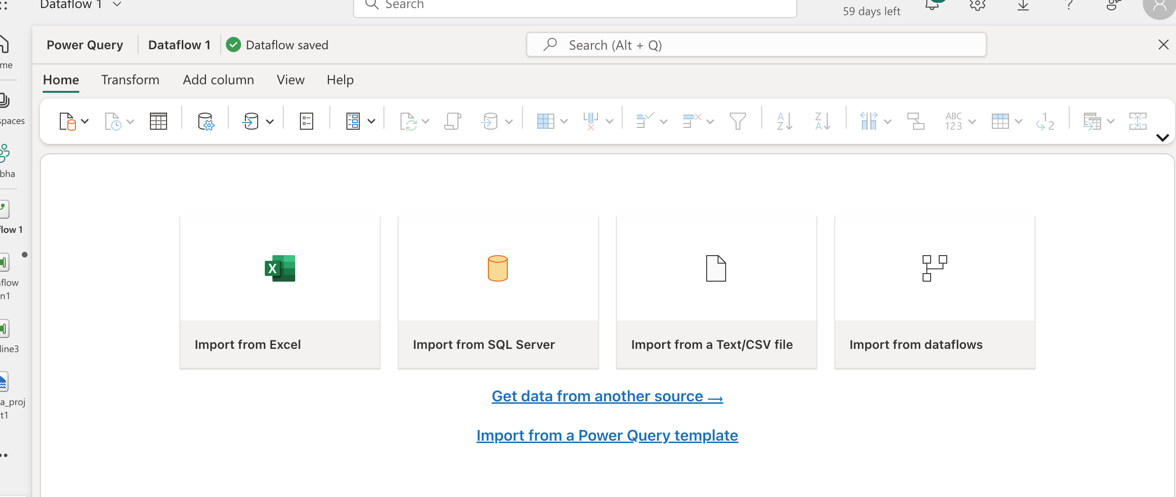 Now to get the source we need to create a connection , for that click new source 🡪 choose source 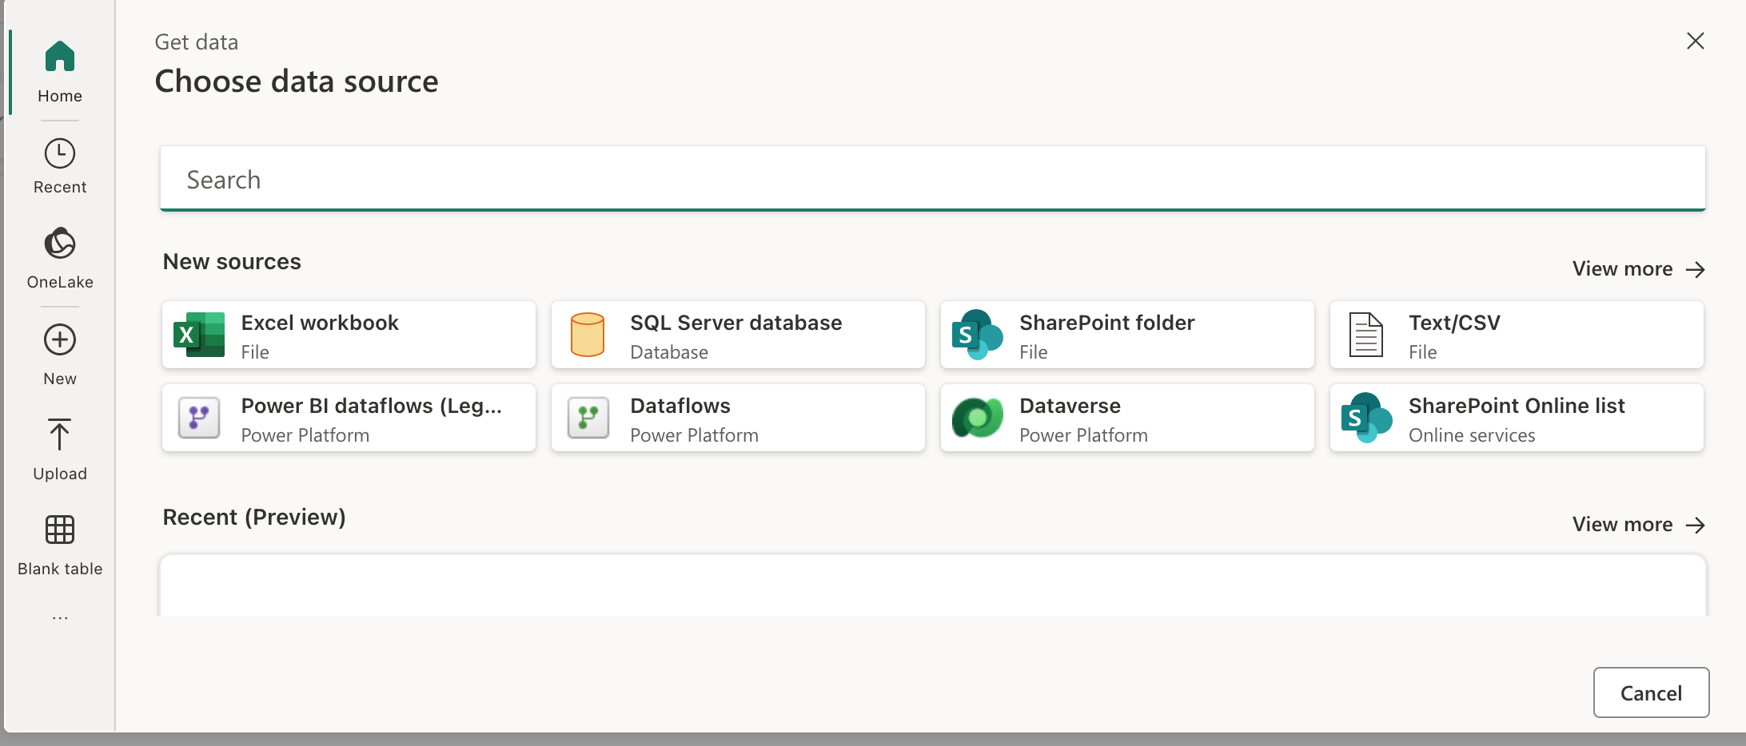

here we can search for any source that we want , I am looking for lakehouse so search it and select it

Once lakehouse is selected , we it create a connection automatically to all the available workspaces 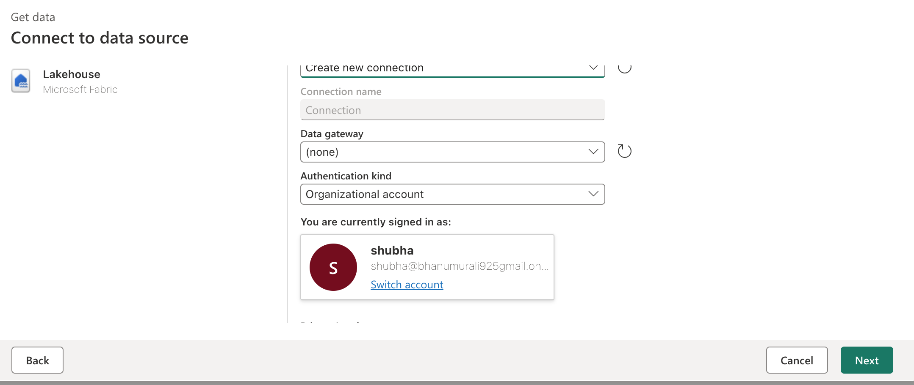 Now we want to select which workspace lakehouse we want and what is the source from the lakehouse file or table 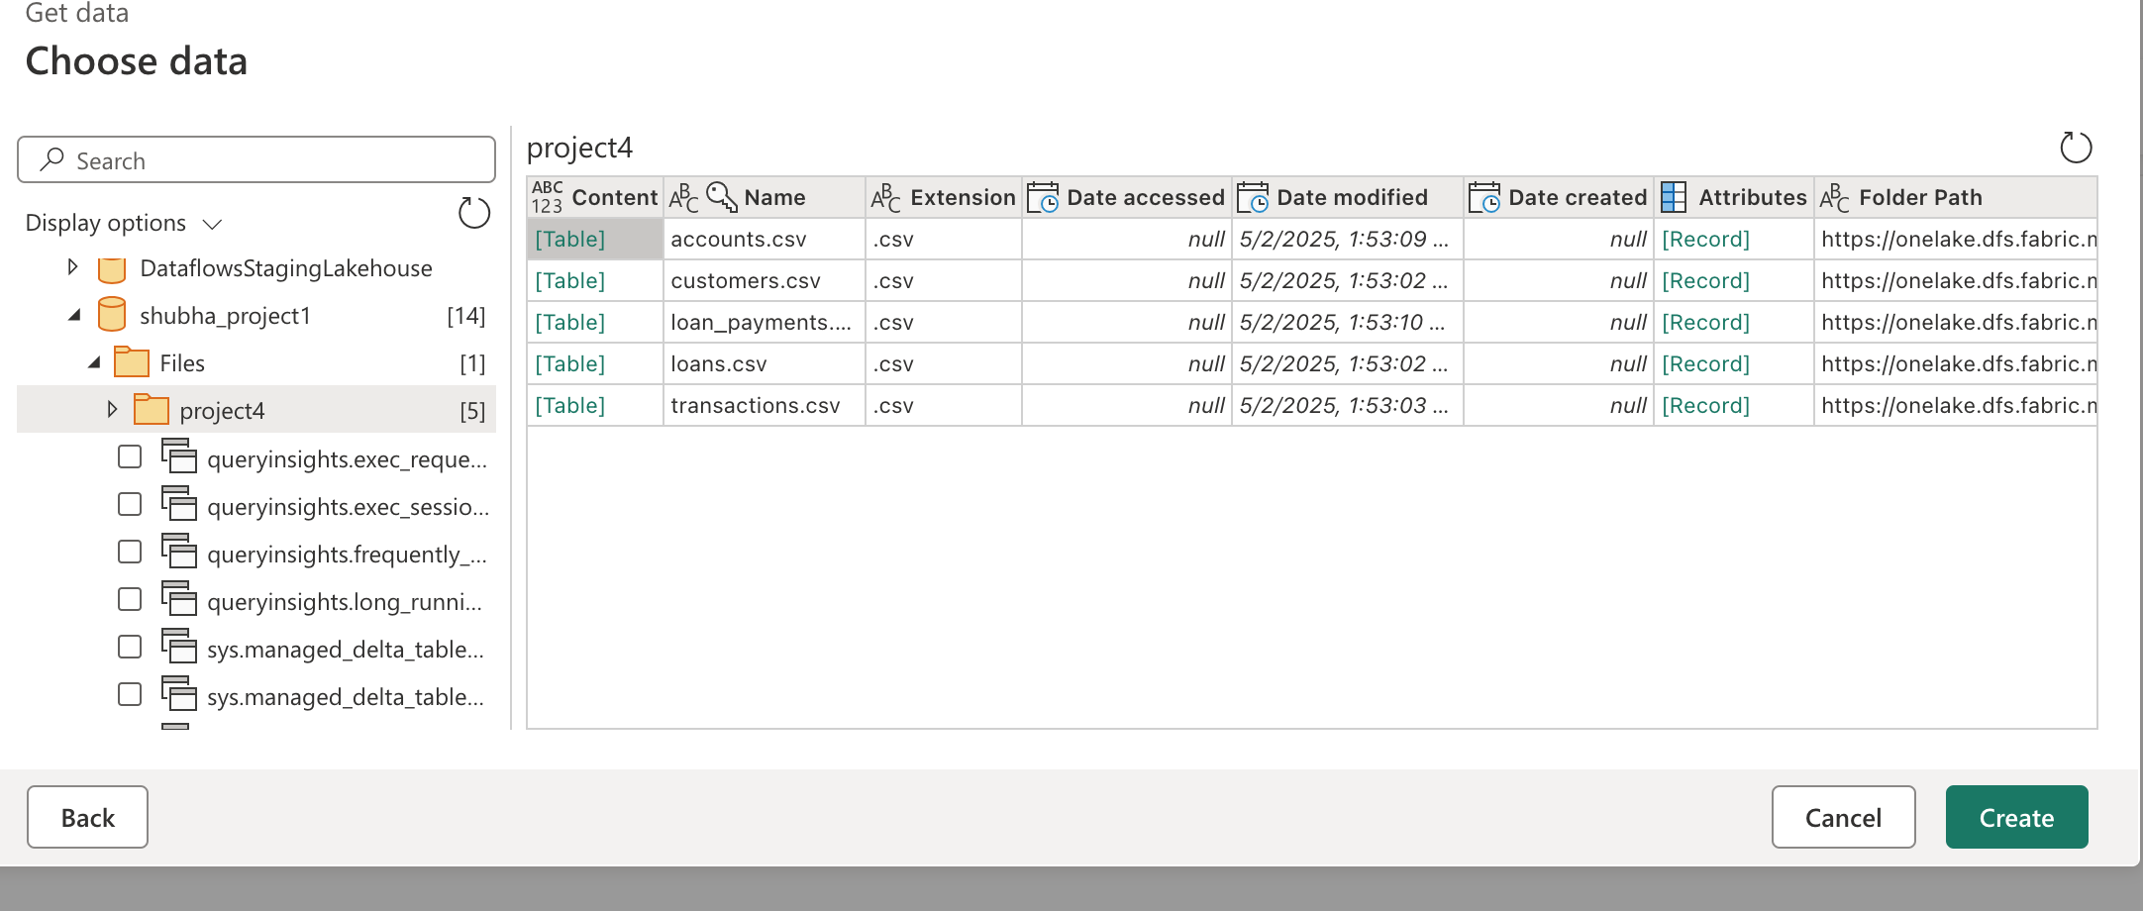 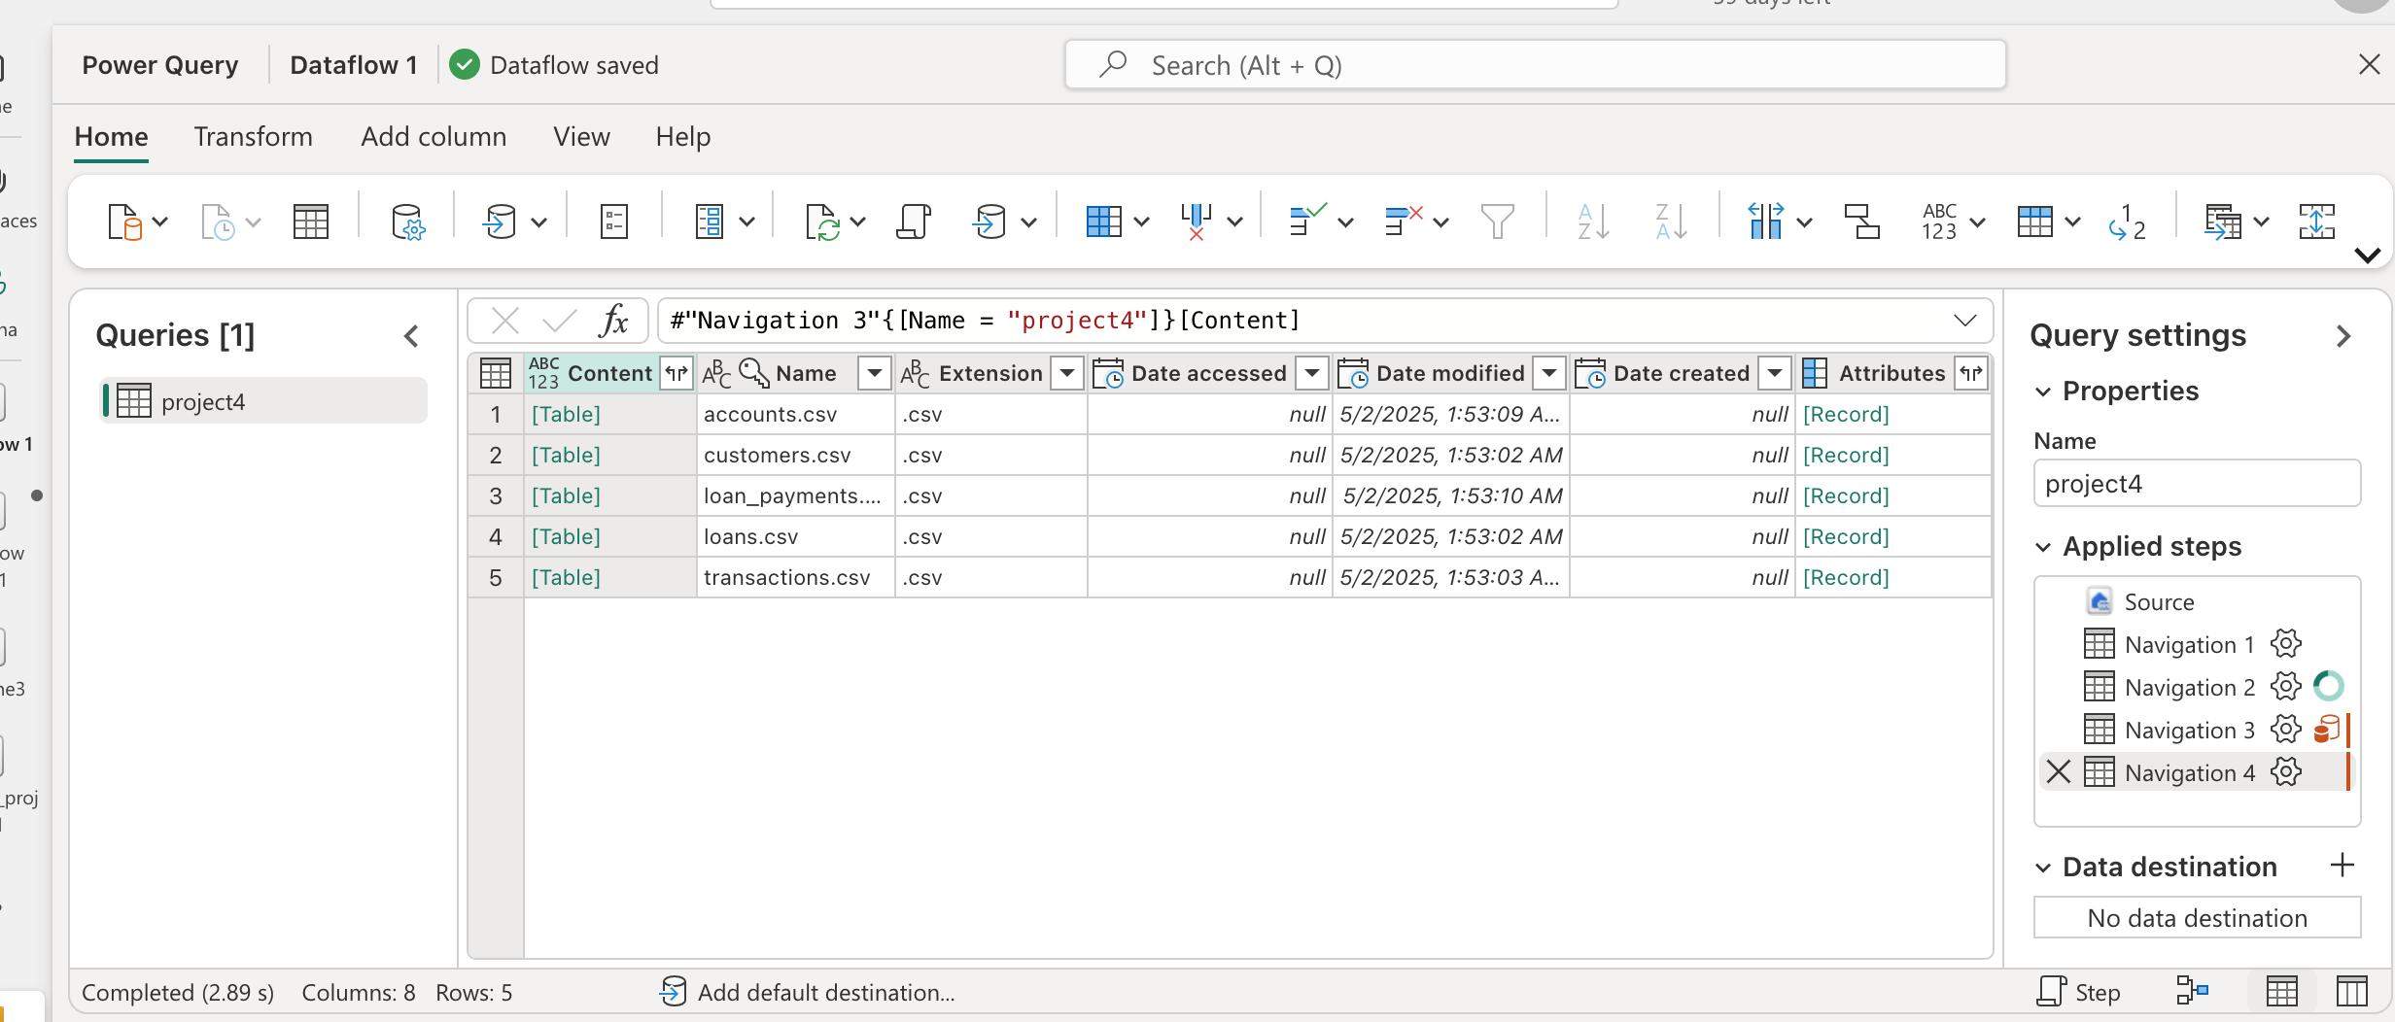 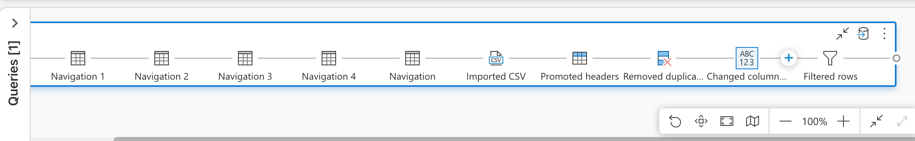 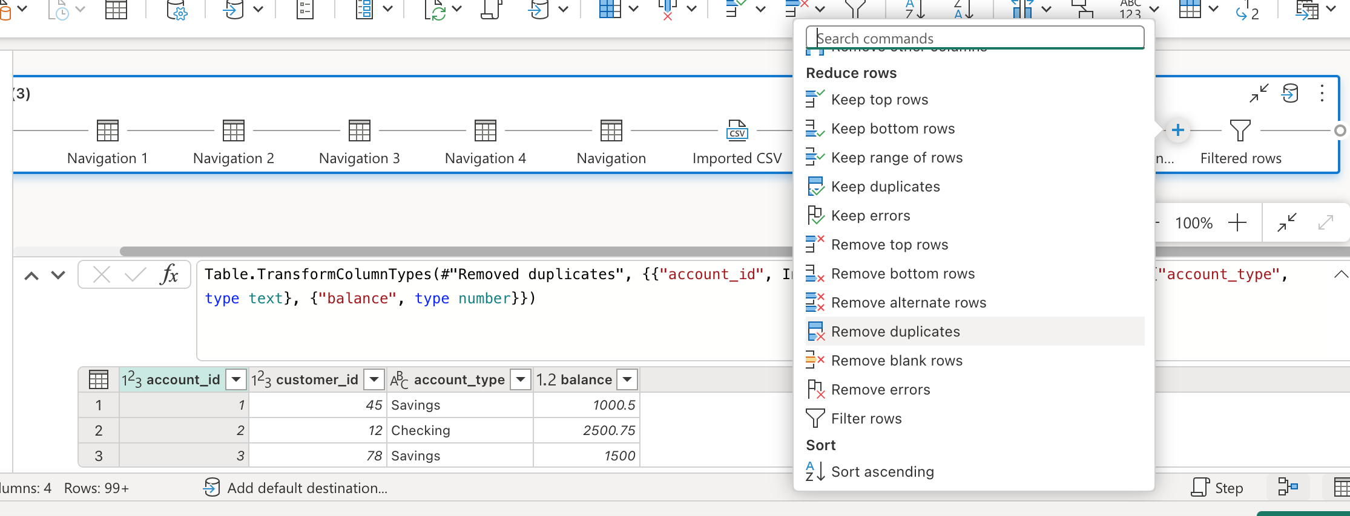 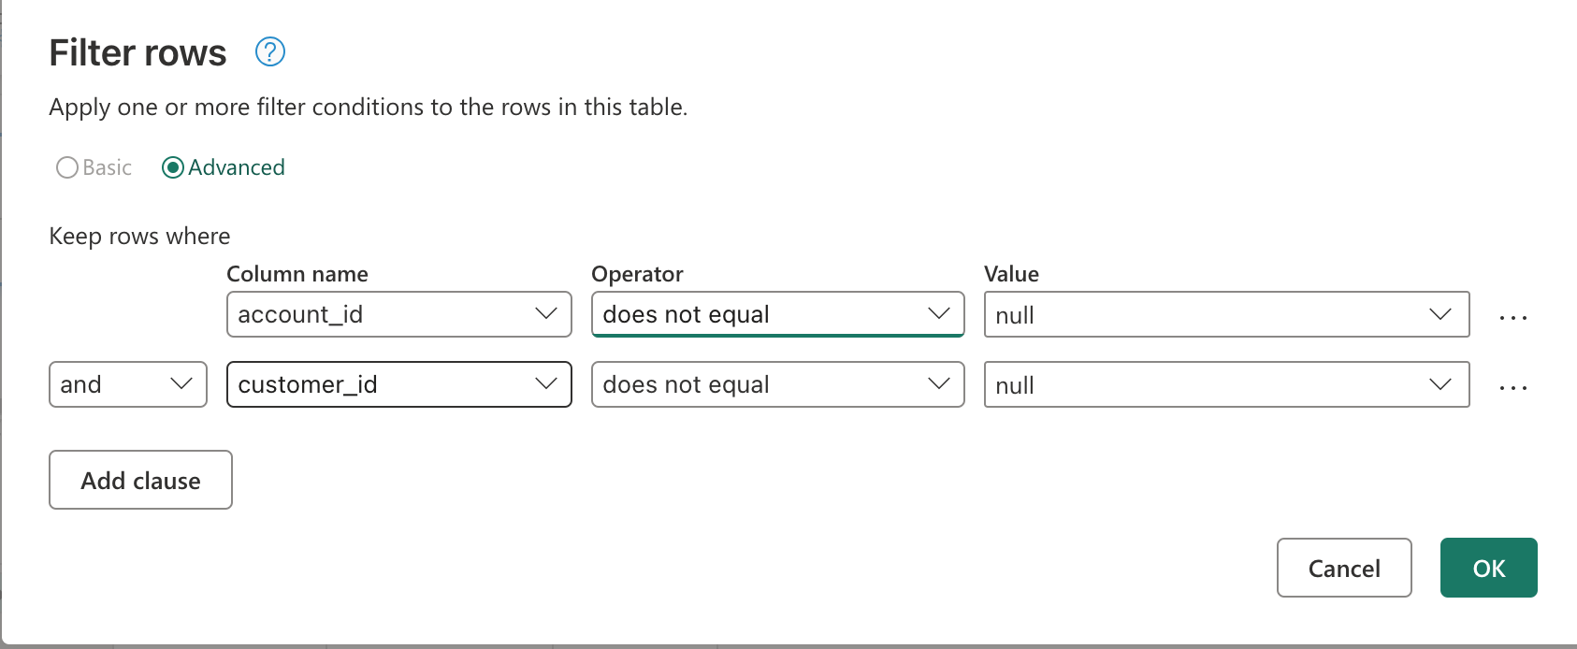 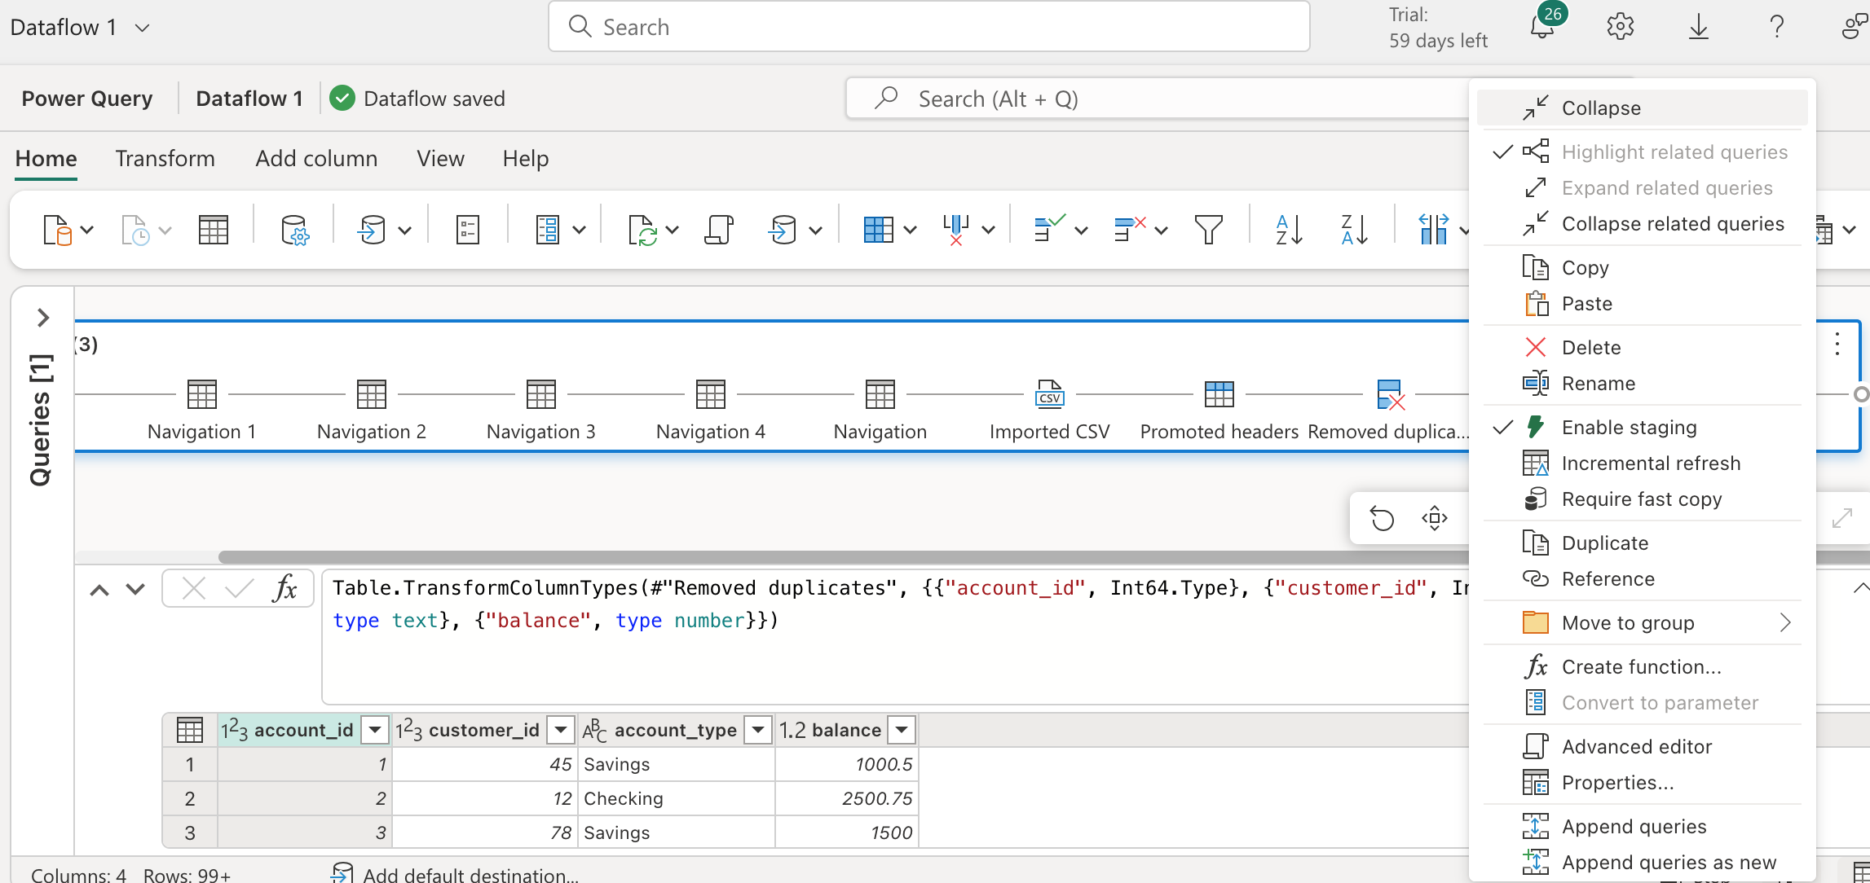 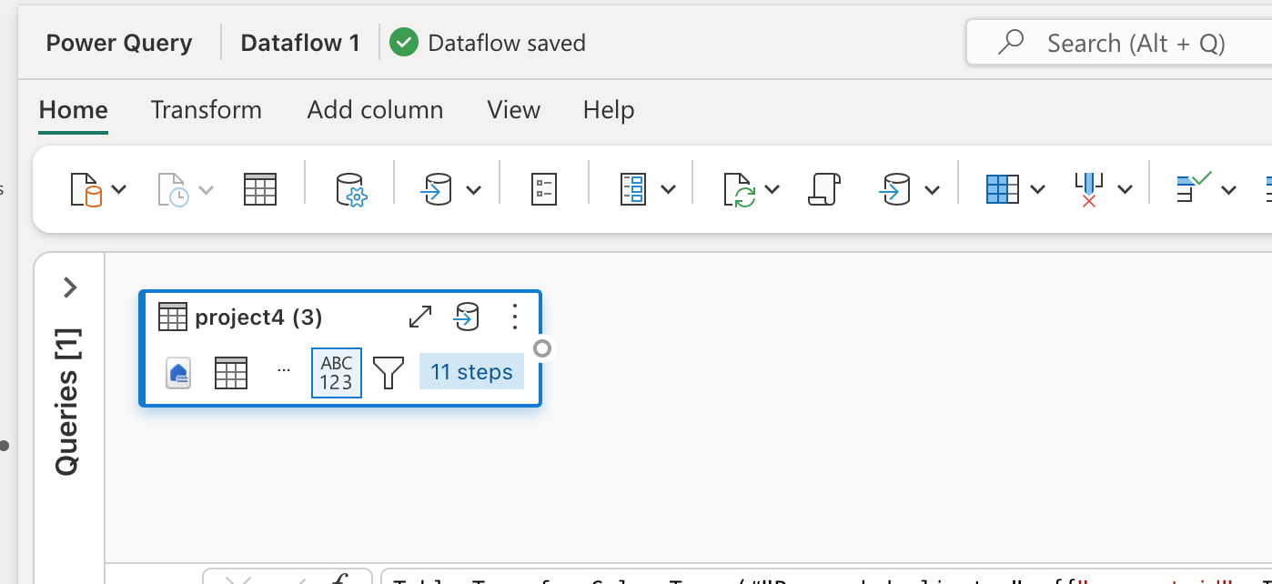 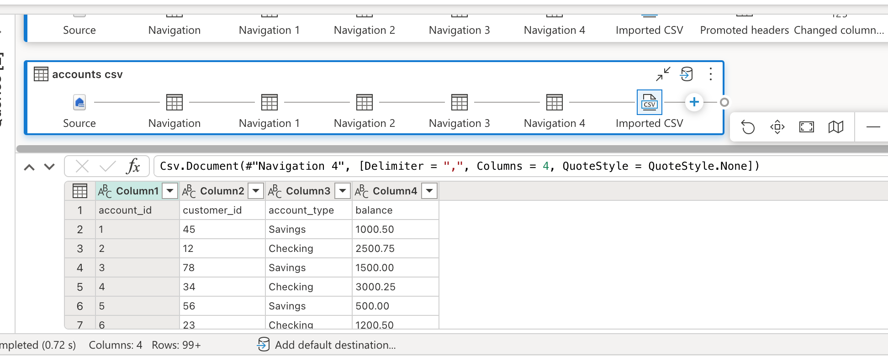 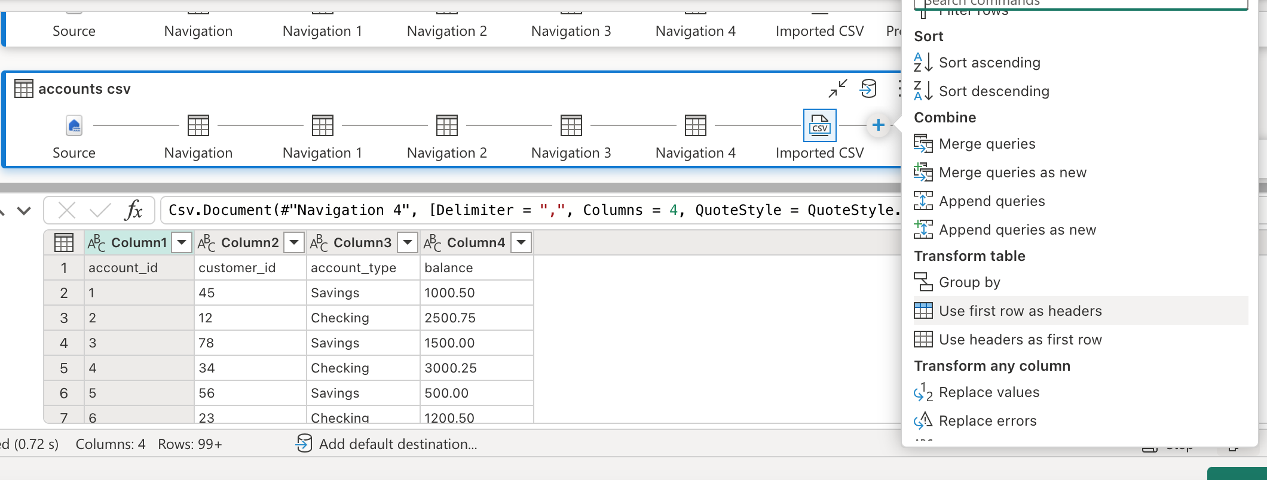 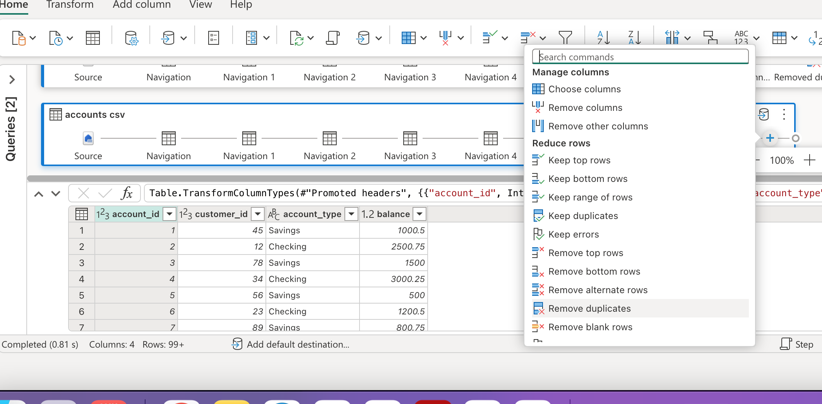 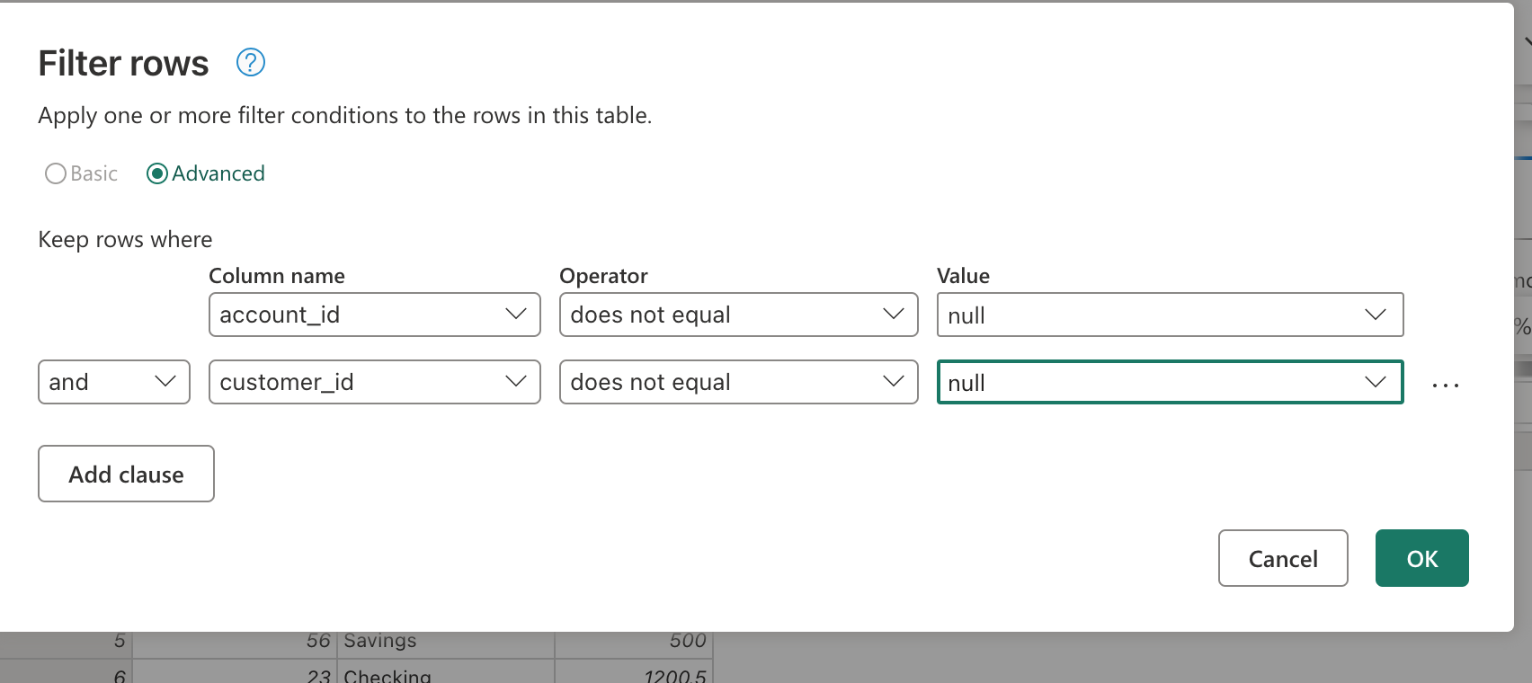 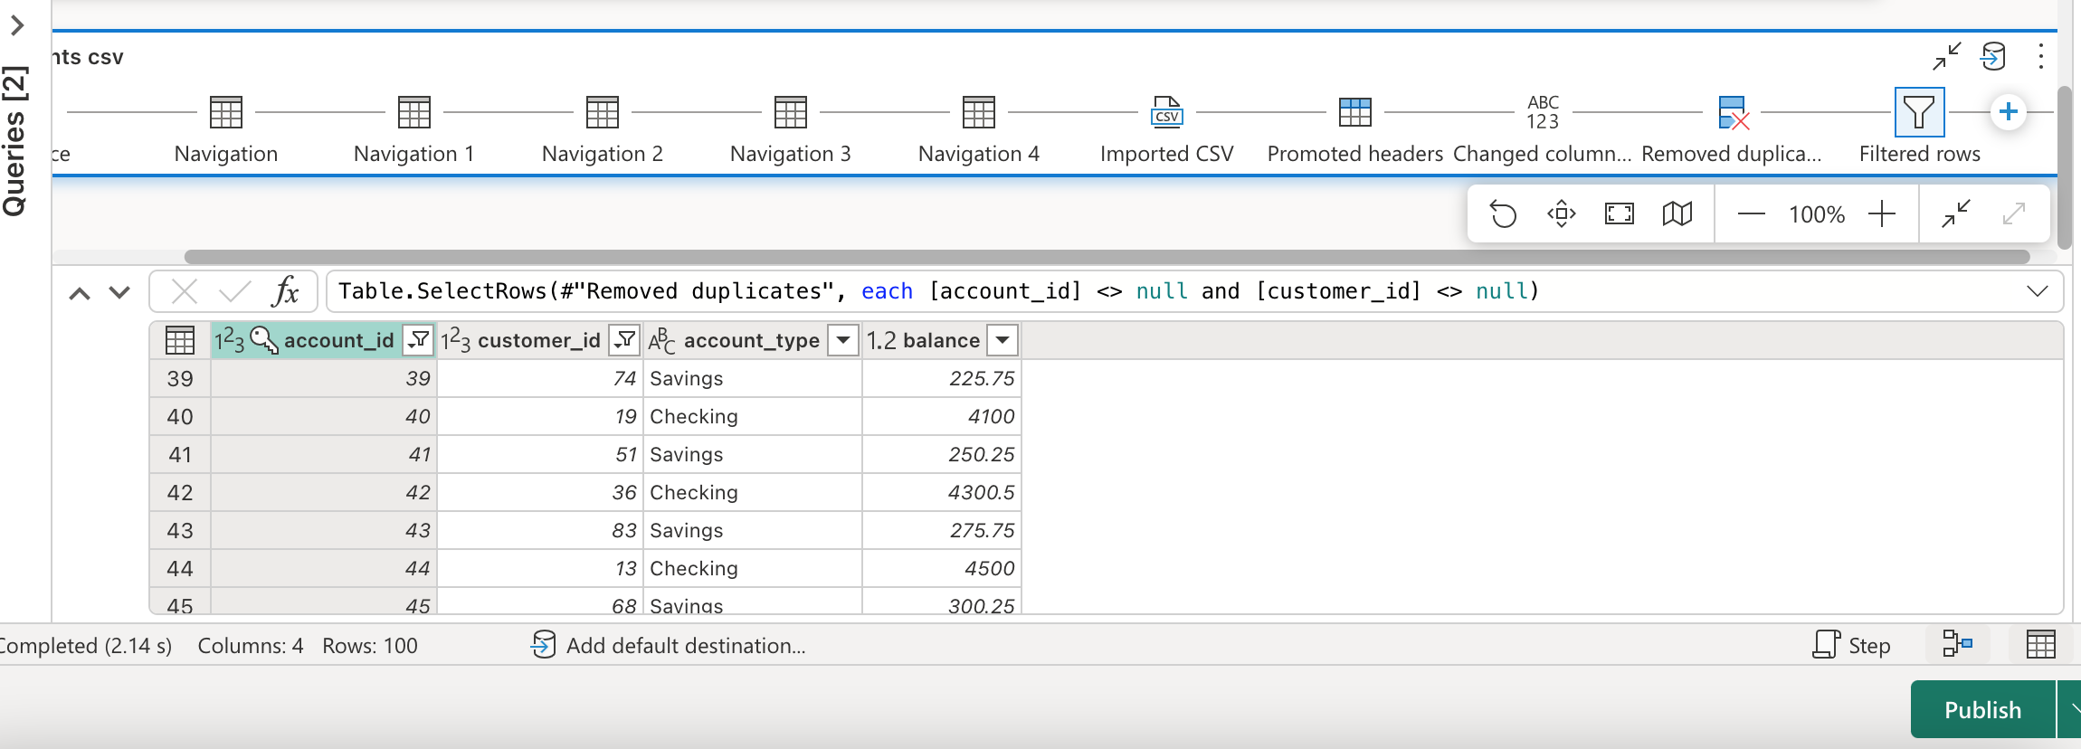 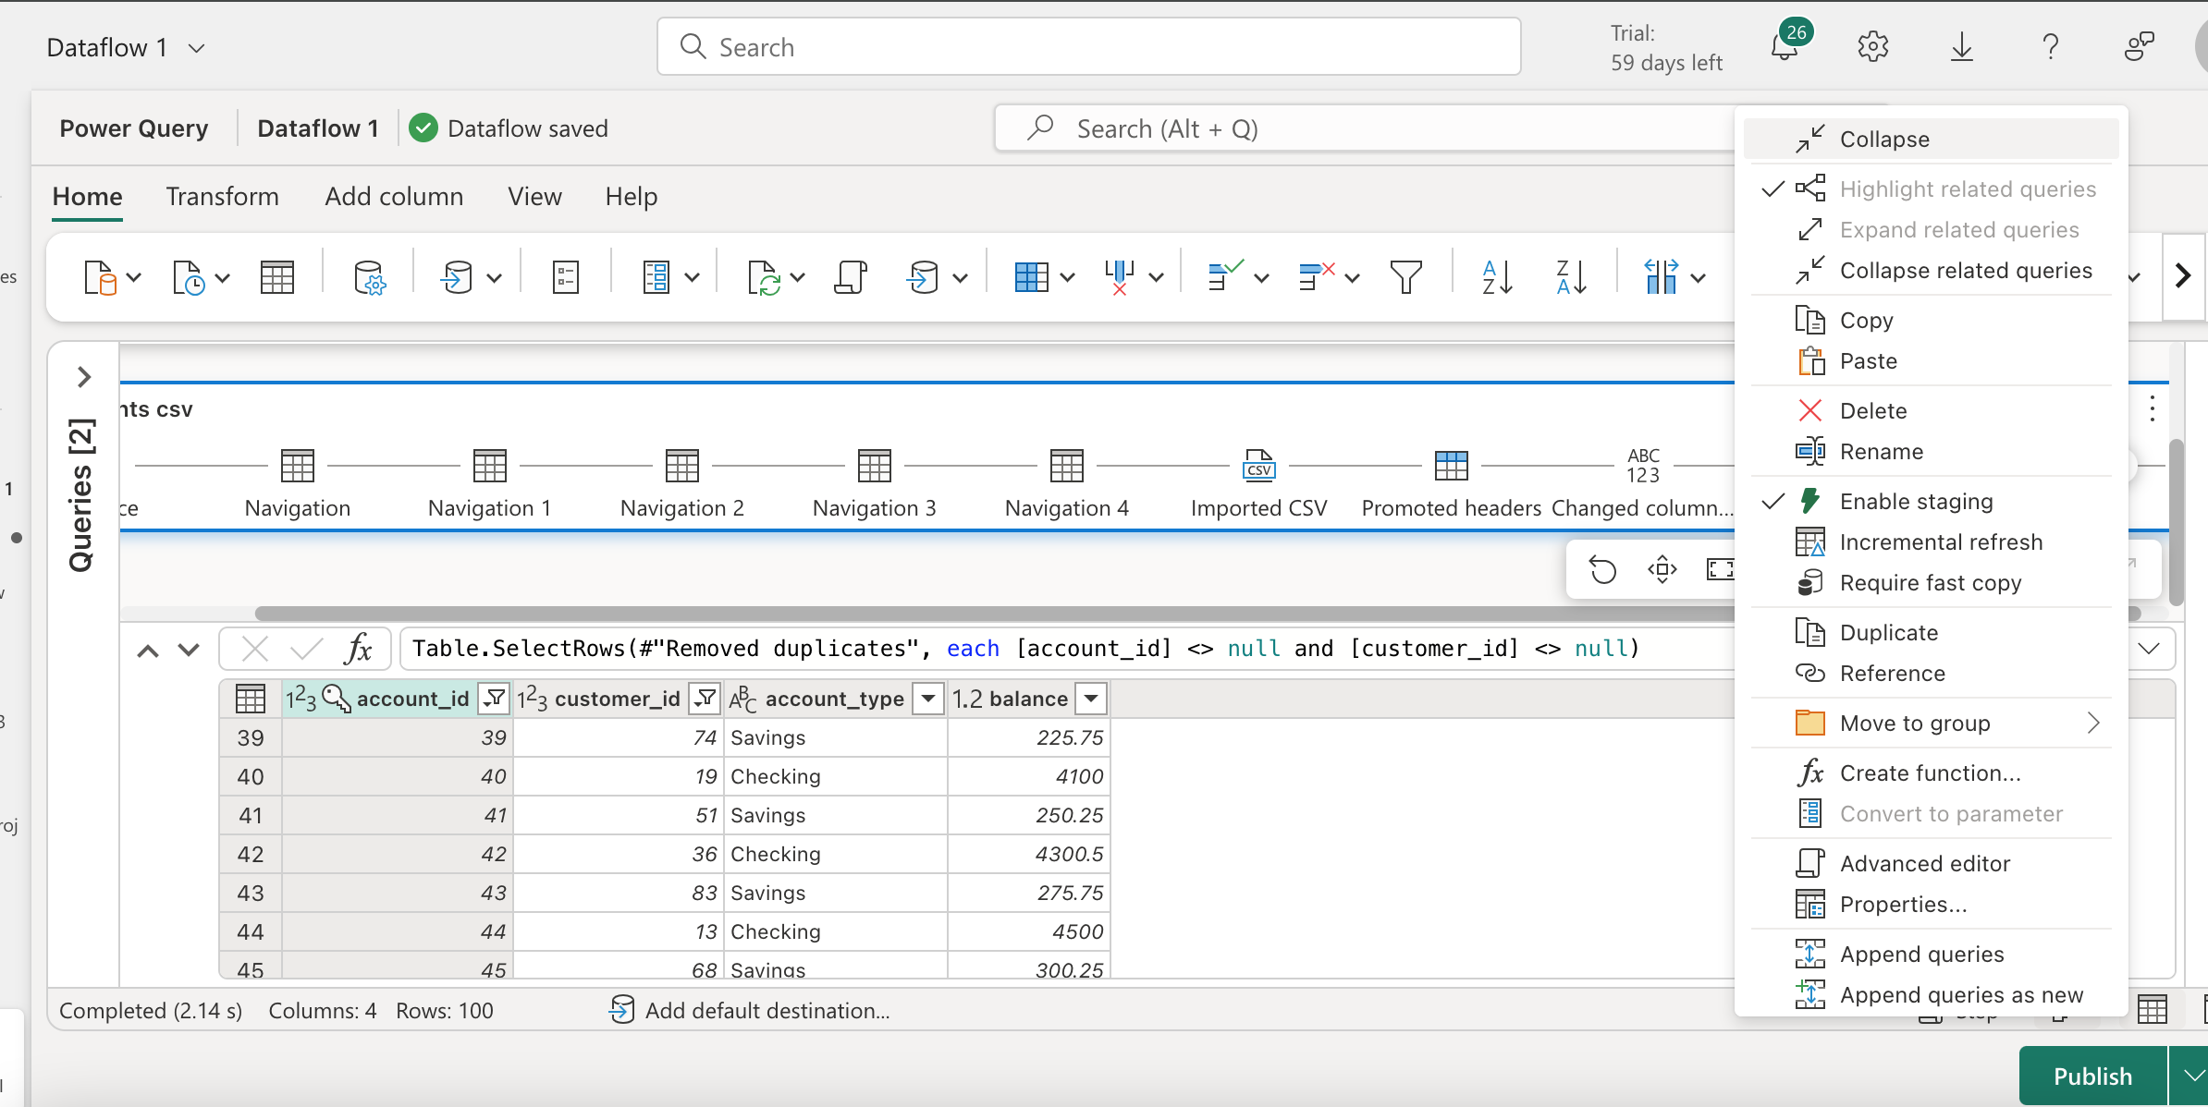 add a destination for warehouse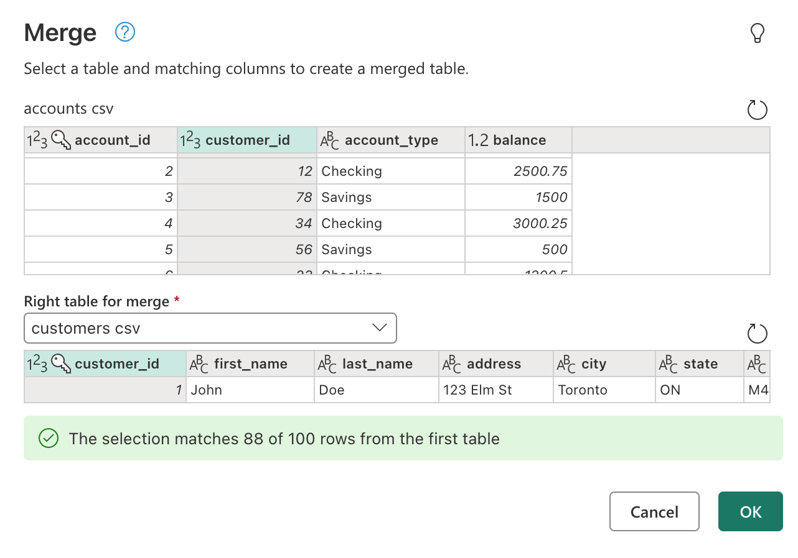 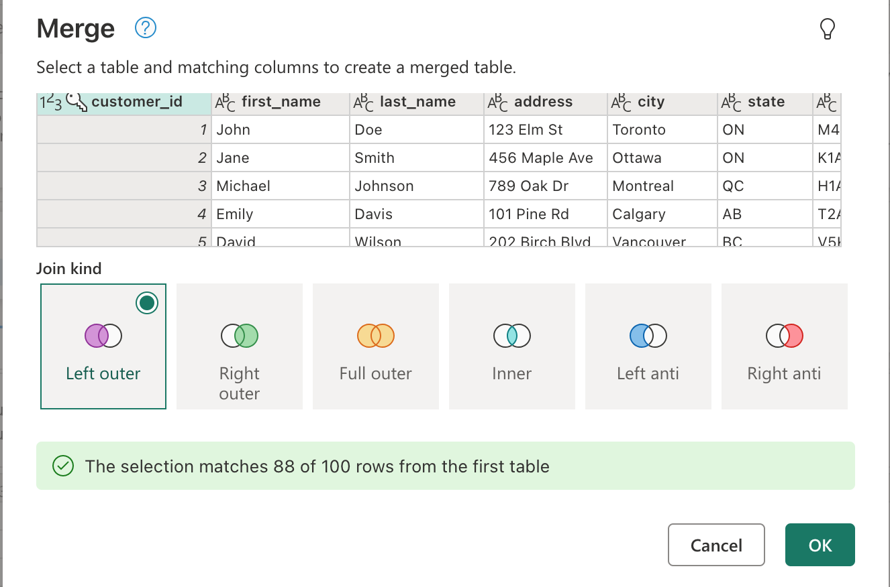

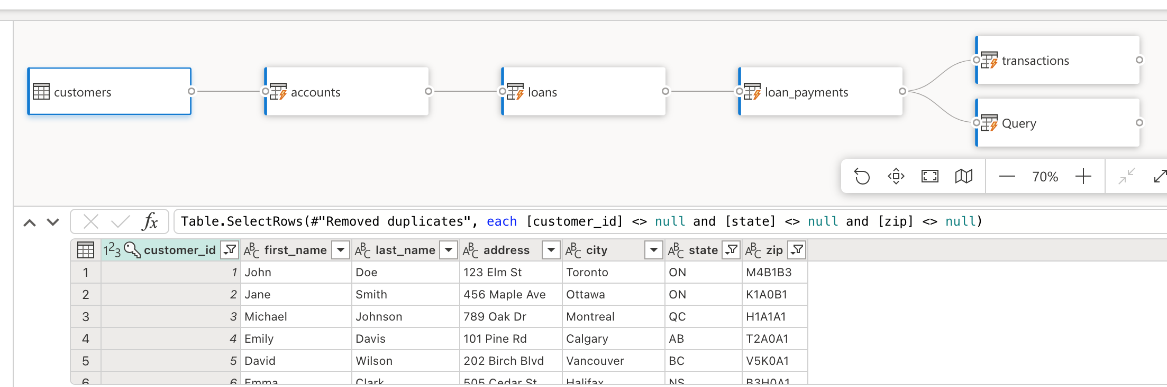data got successfully loaded in data warehouse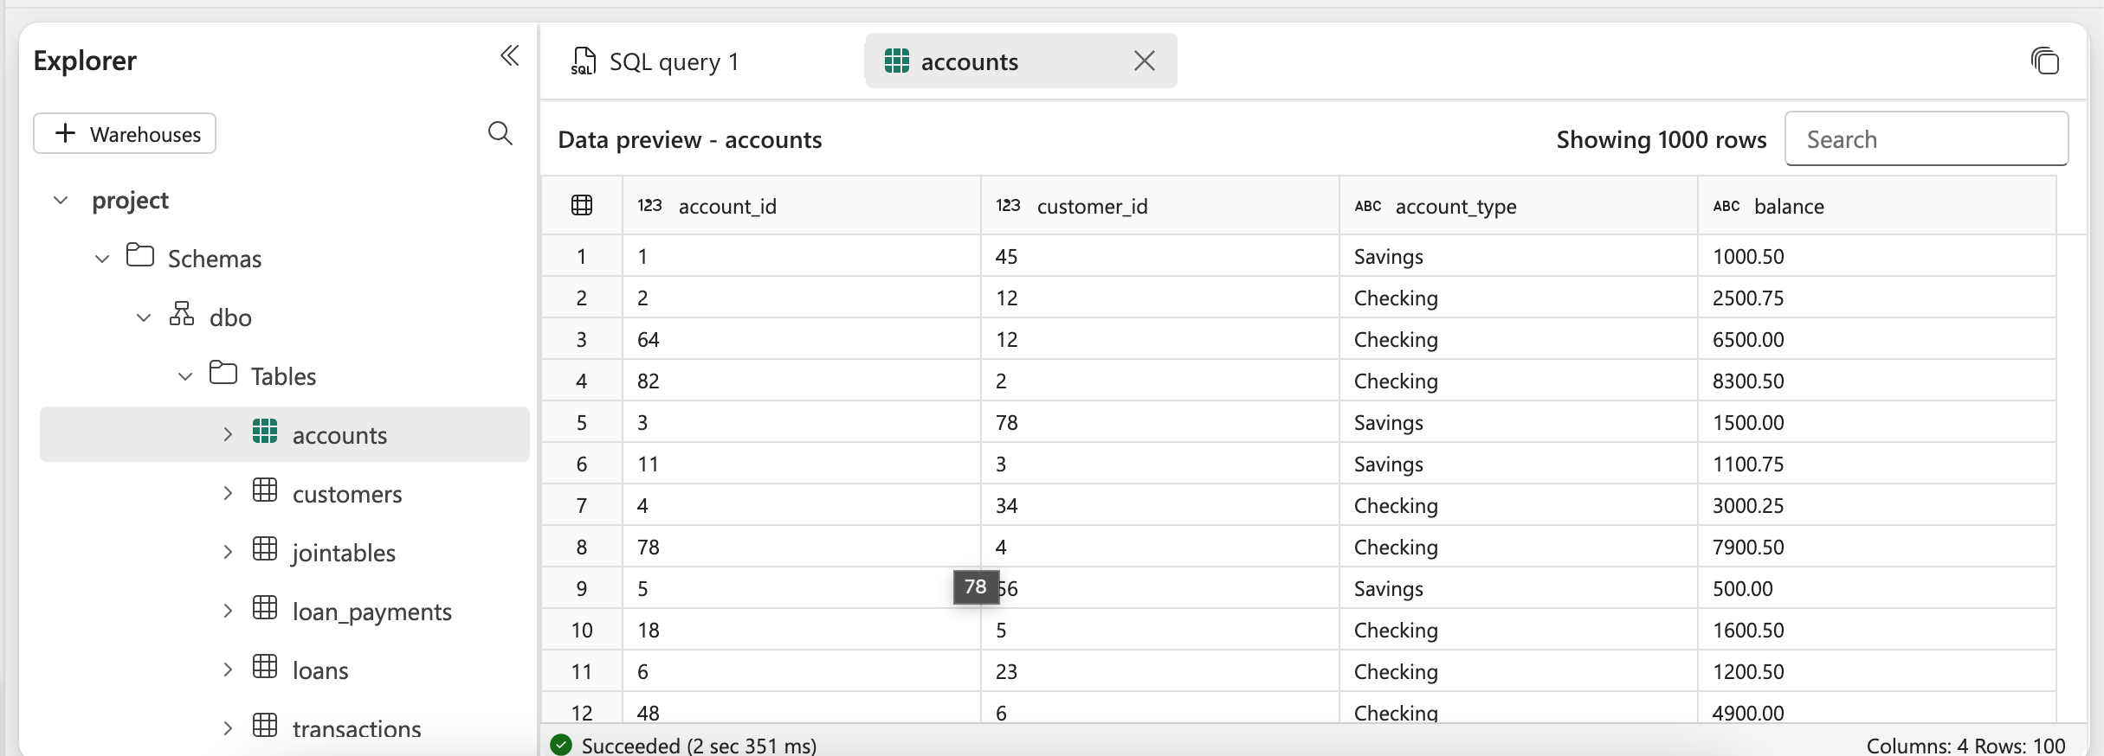**Transforming data into SCD type 1 logic**

To access the tables from warehouse create shortcut in lake house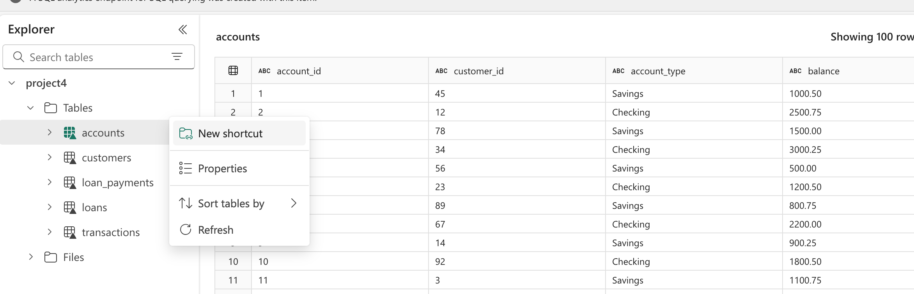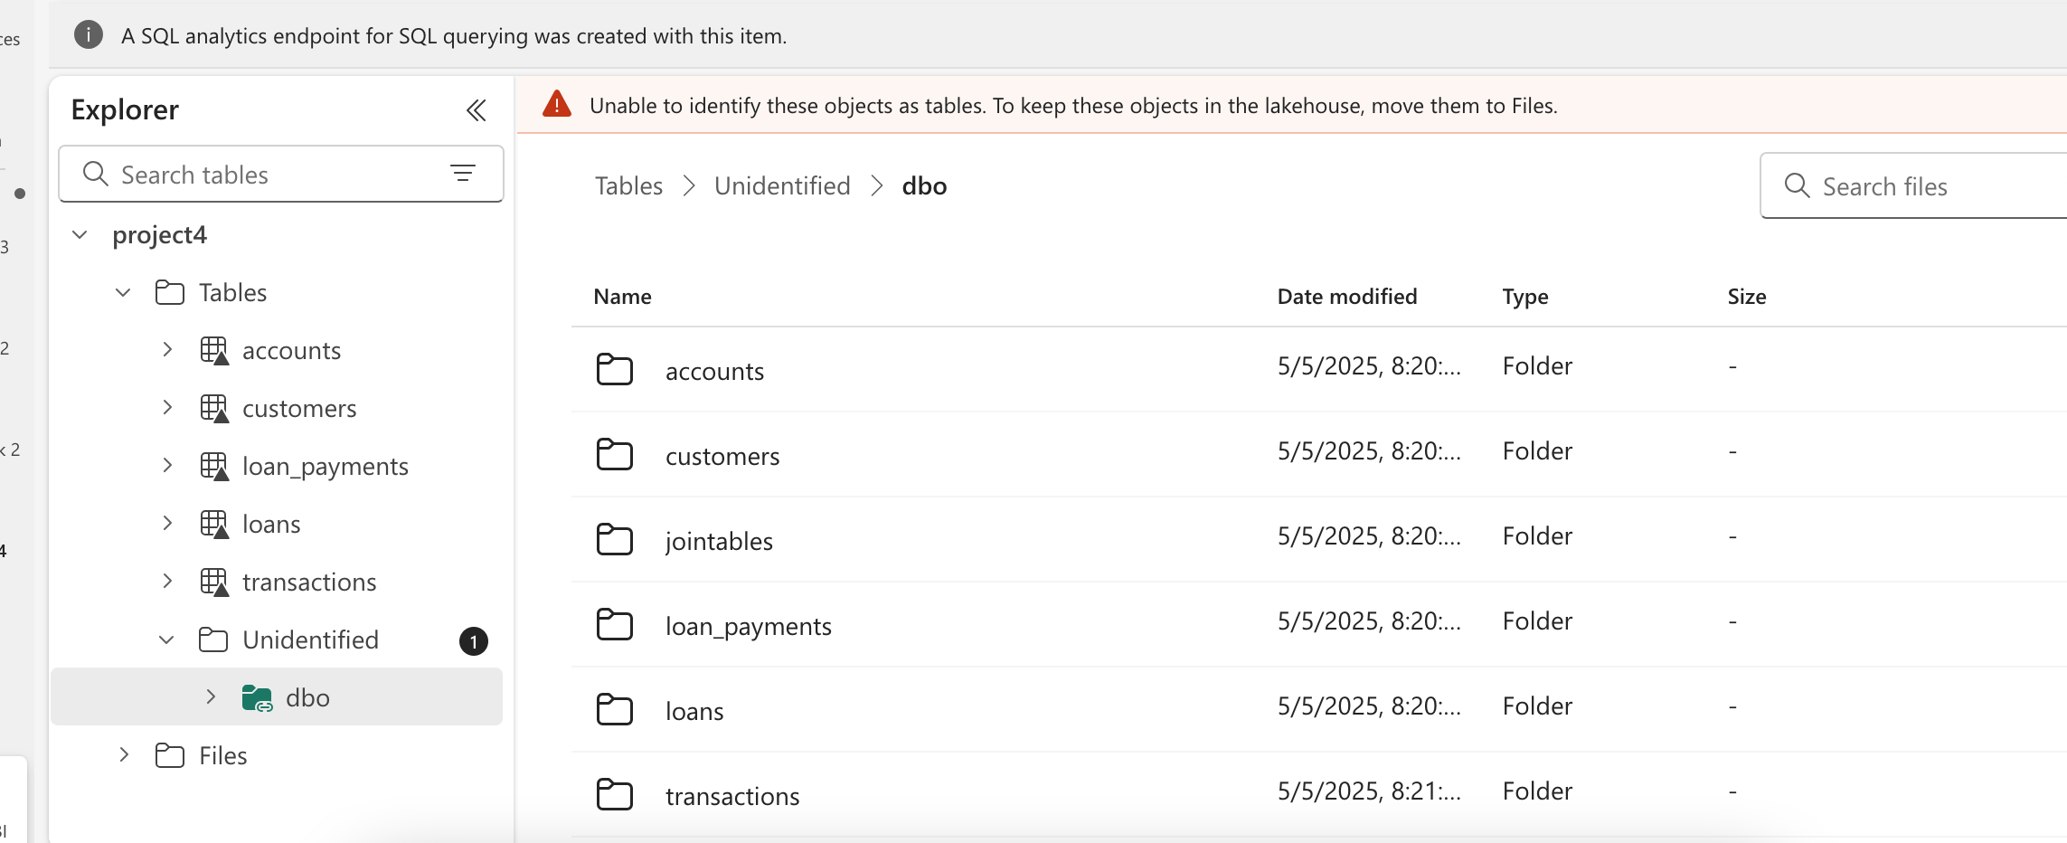SCDTYPE 1 logic using Fabric Notebook

